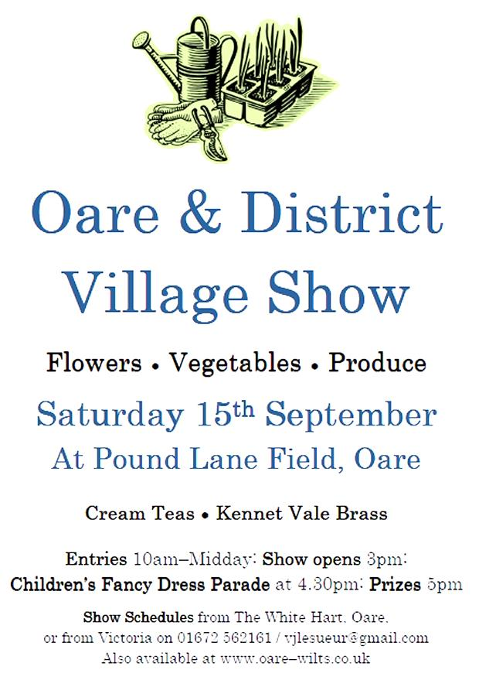

**Presenting the 10th**

**Ashburnham and Penhurst**

**Flower Show and Country Fair**

**Saturday 29 July 2017**

**2pm to 5pm**

**Sports Field, Ashburnham**

**Battle TN33 9NU**

**Schedule of Classes**



Vegetables and Fruit

|  |  |
| --- | --- |
| 1 | 3 Potatoes |
| 2 | 6 Runner Beans |
| 3 | 6 French Beans |
| 4 | 3 Courgettes |
| 5 | 3 Onions (without tops) |
| 6 | 8 Shallots (without tops) |
| 7 | Bunch of radishes |
| 8 | 3 Carrots (with tops) |
| 9 | 3 Beetroot (with tops) |
| 10 | 5 chilli peppers |
| 11 | 3 bulbs of garlic without tops |
| 12 | 1 Cucumber |
| 13 | Cherry tomatoes on the vine |
| 14 | 1 named variety tomato of your choice (to be judged on taste) |
| 15 | Smallest ripe tomato |
| 16 | Collection of 5 vegetables, not less than 2 of each kind |
| 17 | Selection of soft fruit on a plate |
| 18 | The longest runner bean |
| 19 | Any weird or misshapen vegetable or fruit, with caption |
| 20 | Collection of three herbs (named) in water |
| 21 | Any other vegetable not in the list above |
| 22 | The Country Gardener: a collection of vegetables, fruits and flowers – not less than two of each kind – to be judged on quality and presentation. Maximum 10 items in all. |

Flowers

|  |  |
| --- | --- |
| 23 | Single rose |
| 24 | Roses, 3 stems * |
| 25 | Dahlia, any type, 3 blooms * |
| 26 | Sweet peas, 5 stems * |
| 27 | Hydrangeas, 5 stems * |
| 28 | A vase of mixed annuals † |
| 29 | A vase of mixed perennial flowers † |
| 30 | An all-white arrangement with foliage † |
| 31 | A hanging basket, maximum 15” diameter, annuals or perennials, to be judged on overall effect |
| 32 | A summer wreath |
|  | * May be single colour, or mixed  †  All items must be home grown |
|  |  |

Produce

|  |  |
| --- | --- |
| 33 | Jar of homemade jam * |
| 34 | Jar of homemade marmalade * |
| 35 | Jar of homemade jelly * |
| 36 | Jar of homemade lemon curd |
| 37 | Jar of homemade chutney * |
| 38 | 6 hens’ eggs |
| 39 | Loaf of savoury bread, labelled with flavouring used |
| 40 | A plaited loaf |
| 41 | 4 cheese scones |
| 42 | Victoria Sandwich (3 eggs – not exceeding 8” diameter) |
| 43 | Any cake using vegetable(s) (show list of ingredients) |
| 44 | 4 chocolate brownies |
| 45 | A Battenburg cake |
| 46 | Cake of your choice made by a man |
| 47 | 1 bottle of non-alcoholic homemade cordial or squash * |
| 48 | 1 bottle of homemade alcoholic drink * |
| 49 | 4 gluten-free fruit scones (show list of ingredients) |
| 50 | A gluten free cake – any type or size (show list of ingredients) |

* Please specify the variety on a label attached to the exhibit

**Please note that all entries for classes 39-46 and 49-50 must be covered with cling film.**

Photography, arts and craft

|  |  |
| --- | --- |
| 51 | A painting by the exhibitor—any medium—any size |
| 52 | A handmade cushion cover |
| 53 | A drawing—any size |
| 54 | A hand-sewn item of clothing |
| 55 | An item of calligraphy – no larger than A4 size |
| 56 | A hand-made “Get Well” card |
| 57 | A small toy made from any material |
| 58 | A photograph of Ashburnham or Penhurst architecture (max size 7” x 5”) |
| 59 | A photograph on the theme of “Water” (max size 7” x 5”) |
| 60 | A photograph of a pet (max size 7” x 5”) |
| 61 | A black and white portrait photograph (max size 7” x 5”) |
| 62 | A poem written by the exhibitor on the theme of “Country Ways”  (8-12 lines) |
| 63 | An original piece of prose writing—fiction or non-fiction—max 500 words |
| 64 | A computer-generated piece of art |
| 65 | A limerick with the first line: “A WI member called Pam…” |
| 66 | A limerick with the first line: “There was a young farmer called Stan…” |

Aged 8 and under

|  |  |
| --- | --- |
| 67 | **Pre-schoolers only:** A collage using fabric |
| 68 | **Pre-schoolers only:** A picture of “my house” |
| 69 | A spider on a web on a paper plate using art and craft material |
| 70 | A finger painting of a butterfly |
| 71 | A scary monster made from fruit and/or vegetables |
| 72 | 4 decorated gingerbread men |
| 73 | An A4 size self portrait |
| 74 | A plate of homemade sweets |
| 75 | A necklace made of natural materials |
| 76 | A model made from Lego |
| 77 | An animal mask |
| 78 | Best handwriting – see text below |
| 79 | An edible rainbow on a plate |
|  |  |

**Text for class 78**

I am a crab who walks the shore

And pinches toes all day.

If I were you, I’d wear some shoes

And not get in my way.

Aged 16 and under

|  |  |
| --- | --- |
| 80 | A computer-generated picture on a sports-related theme |
| 81 | A picture made from pasta and/or pulses |
| 82 | An arrangement of garden flowers in an egg cup |
| 83 | A handmade “Get Well” card |
| 84 | A photograph entitled *My pet” |
| 85 | Decorated container for pens and pencils |
| 86 | “Bling up” your teddy bear |
| 87 | 4 chocolate brownies |
| 88 | A hand-made soft toy or puppet |
| 89 | A painting of a bird |
| 90 | Best handwriting – for text see below |

**Text for class 90**

“Is there anybody there?” said the Traveller,

Knocking on the moonlit door;

And his horse in the silence champed the grasses

Of the forest’s ferny floor:

And a bird flew up out of the turret,

Above the Traveller’s head:

And he smote upon the door again a second time;

“Is there anybody there?” he said.

**Rules for Competitors**

* Only one exhibit per person may be entered in any one class.
* All fruit, vegetables, herbs and flowers must be grown by the exhibitor.
* All produce, photography, art, crafts and junior class entries must be the work of the exhibitor.
* Judges may withhold prizes if they consider the exhibits not worthy of winning, or if there are insufficient entries in a class.
* Reasonable care will be taken of the exhibits but the committee cannot accept any claims for damage or loss.
* The judges’ decisions are final.
* All exhibits must be staged between 8.30am and 10am on 29 July, after which time no other exhibits will be accepted and only the judges and stewards may remain in the tent until the end of judging.
* All cakes, biscuits, breads and other cooked food must be covered with cling film before being exhibited.
* Exhibits must be left in position until 4pm and should be removed before 4.30pm. Any exhibits left in the tent after that time will be sold for show funds.
* Prize money not collected by 4.30pm on 29 July will be taken as a donation to show funds.
* **Exhibits should be entered on the entry form included in this schedule (or a photocopy), and should be submitted with entry fees of 30p per class no later than Wednesday 26 Julyto one of the collection addresses on page 9. Late entries may be accepted but only at the discretion of the organisers, who reserve the right to refuse entries submitted after this date.**
* Any queries should be directed to Jennifer Oldroyd on 01323 832748, or by email to [jennifer.oldroyd@btinternet.com](mailto:jennifer.oldroyd@btinternet.com).

**Further copies of this schedule may be downloaded from the village website at:** [**www.ashburnham-penhurst.net**](http://www.ashburnham-penhurst.net)

**PRIZES AND AWARDS**

to be presented at 4.30pm

In all classes the prize money will be as follows:

1st Prize: 50p 2nd Prize: 30p 3rd Prize: 20p

In all classes, points will be awarded as follows:

1st Prize: 4 points 2nd Prize 2 points 3rd Prize: 1 Point

**The Eric White Memorial Trophy** will be awarded to the exhibitor achieving the most points across the show.

**The Jim Payne Floral Arrangement Trophy** will be awarded to the winner of class 32.

**The Roy White Country Gardener Trophy** will be awarded to the winner of class 22.

**The Royal Horticultural Society Banksian Medal** will be awarded to the exhibitor achieving the most points in the Vegetables and Fruit section.

Section trophies will be awarded to the exhibitors achieving the most points in the following sections: Flowers; Photography, Arts and Crafts; Produce; Junior Classes (age 8 and under); Junior Classes (age 16 and under).

_____________________________________________________

**Following the prize-giving any exhibits remaining in the marquee will be sold for show funds. Any items you do not want to be sold should be removed from the marquee by 4.30pm.**

_____________________________________________________

**FEES AND ENTRY FORMS**

**The entry fee is 30p per exhibit.** **All entry forms and fees should be submitted by Wednesday 26 July to any of the following collection points. Late entries may be accepted but only at the discretion of the organisers, who reserve the right to refuse entries submitted after this date.**

Gill and Robin Ratcliffe, The Old Shop, Ponts Green, Ashburnham, Battle TN33 9PD

John and Tina French, Pound Cottage, The Pound, Ashburnham, Battle TN33 9NR

Richard Hann, The Manor House, Penhurst, Battle TN33 9QP

**ASHBURNHAM AND PENHURST FLOWER SHOW**

**SATURDAY 29 JULY 2017**

**ENTRY FORM**

Please complete in block capitals and return, with entry fees, to one of the addresses shown

on page 9.

|  |  |  |
| --- | --- | --- |
| Name | |  |
| Age (if 16 or under) | |  |
| Email address: | |  |
| Street address | |  |
|  | |  |
| Phone number | |  |
| *These details will only be used for matters relating to the Ashburnham and Penhurst Flower Show and will not be passed to a third party.* | | |
| I wish to enter the following classes: | |  |
|  |
|  |
| Please tick | | |
|  | I have read and will comply with the “Rules for Exhibitors” | |
|  | I enclose a fee of 30p per class entered | |
|  | | |
| Signed | |  |